Missing Race_of_Father Analysis Report
Generated: 2026-03-21 18:57
Dataset: 336,097 rows × 18 columns
Target Variable: Race_of_Father

1. Executive Summary
This report presents a comprehensive IUPAC-compliant statistical analysis of missing values in Race_of_Father.
Key findings include:
• Missing records: 221 (0.1% of total data)
• Variables with significant differences (p < 0.05): 11
- Numeric variables: 4
- Categorical variables: 7
• Total variables analyzed: 17
Based on the statistical analysis, the missingness pattern is classified as:
SYSTEMATIC PATTERN - Missing data is strongly associated with other variables, suggesting non-random missingness.

2. Statistical Summary
Metric | Value
Total Missing Race_of_Father Records | 221
Missing Percentage | 0.07%
Total Variables Analyzed | 17
Numeric Variables | 7
Categorical Variables | 10
Variables with Significant Differences (p < 0.05) | 11
Analysis Date | 2026-03-21

3. Variables with Significant Differences (p < 0.05)
The following 11 variables show statistically significant differences between missing and complete groups:

3.1 Numeric Variables
Variable | Missing Group Mean | Complete Group Mean | Difference | p-value | Interpretation
Birh_Year | 2011.76 | 2014.69 | -2.92 | 0.0000 | Missing group has 2.92 units lower than complete group
Birth_Year_2.0 | 2011.76 | 2014.69 | -2.92 | 0.0000 | Missing group has 2.92 units lower than complete group
TWIN | 1.00 | 1.01 | -0.01 | 0.0000 | Missing group has 0.01 units lower than complete group
Age of Mother | 28.07 | 29.03 | -0.96 | 0.0391 | Missing group has 0.96 units lower than complete group

3.2 Categorical Variables
Variable | Missing Group Distribution | Complete Group Distribution | Difference (%) | p-value | Interpretation
Registered_Month | Most common='November' (12.7%) | Complete: Most common='October' (9.0%) | +3.6% | 0.0139 | Missing group shows different distribution (p=0.0139)
Registered_District | Most common='Gampaha' (32.6%) | Complete: Most common='Colombo' (15.4%) | +17.2% | 0.0000 | Missing group shows different distribution (p=0.0000)
Hospital or Not | Most common='Hospital' (94.6%) | Complete: Most common='Hospital' (99.2%) | -4.6% | 0.0000 | Missing group shows different distribution (p=0.0000)
Birth_Order | Most common='First' (57.0%) | Complete: Most common='First' (44.4%) | +12.6% | 0.0423 | Missing group shows different distribution (p=0.0423)
Marital_Status | Most common='Married' (71.5%) | Complete: Most common='Married' (98.3%) | -26.8% | 0.0000 | Missing group shows different distribution (p=0.0000)
District_of_Mother | Most common='Gampaha' (26.7%) | Complete: Most common='Colombo' (9.4%) | +17.3% | 0.0000 | Missing group shows different distribution (p=0.0000)
Race_of_Mother | Most common='Sinhalese' (93.2%) | Complete: Most common='Sinhalese' (72.2%) | +21.0% | 0.0000 | Missing group shows different distribution (p=0.0000)

3.3 Summary of Key Findings
The analysis identified 11 variables with statistically significant differences (p < 0.05):
• 4 numeric variables show significant mean differences
• 7 categorical variables show significant distribution differences
Top 10 Most Significant Variables:
1. TWIN: Mean=1.00 vs Complete Mean=1.01 (p=0.0000)
2. Marital_Status: Most common='Married' (71.5%) vs Complete: Most common='Married' (98.3%) (p=0.0000)
3. Registered_District: Most common='Gampaha' (32.6%) vs Complete: Most common='Colombo' (15.4%) (p=0.0000)
4. District_of_Mother: Most common='Gampaha' (26.7%) vs Complete: Most common='Colombo' (9.4%) (p=0.0000)
5. Race_of_Mother: Most common='Sinhalese' (93.2%) vs Complete: Most common='Sinhalese' (72.2%) (p=0.0000)
6. Hospital or Not: Most common='Hospital' (94.6%) vs Complete: Most common='Hospital' (99.2%) (p=0.0000)
7. Birh_Year: Mean=2011.76 vs Complete Mean=2014.69 (p=0.0000)
8. Birth_Year_2.0: Mean=2011.76 vs Complete Mean=2014.69 (p=0.0000)
9. Registered_Month: Most common='November' (12.7%) vs Complete: Most common='October' (9.0%) (p=0.0139)
10. Age of Mother: Mean=28.07 vs Complete Mean=29.03 (p=0.0391)

4. Statistical Visualizations
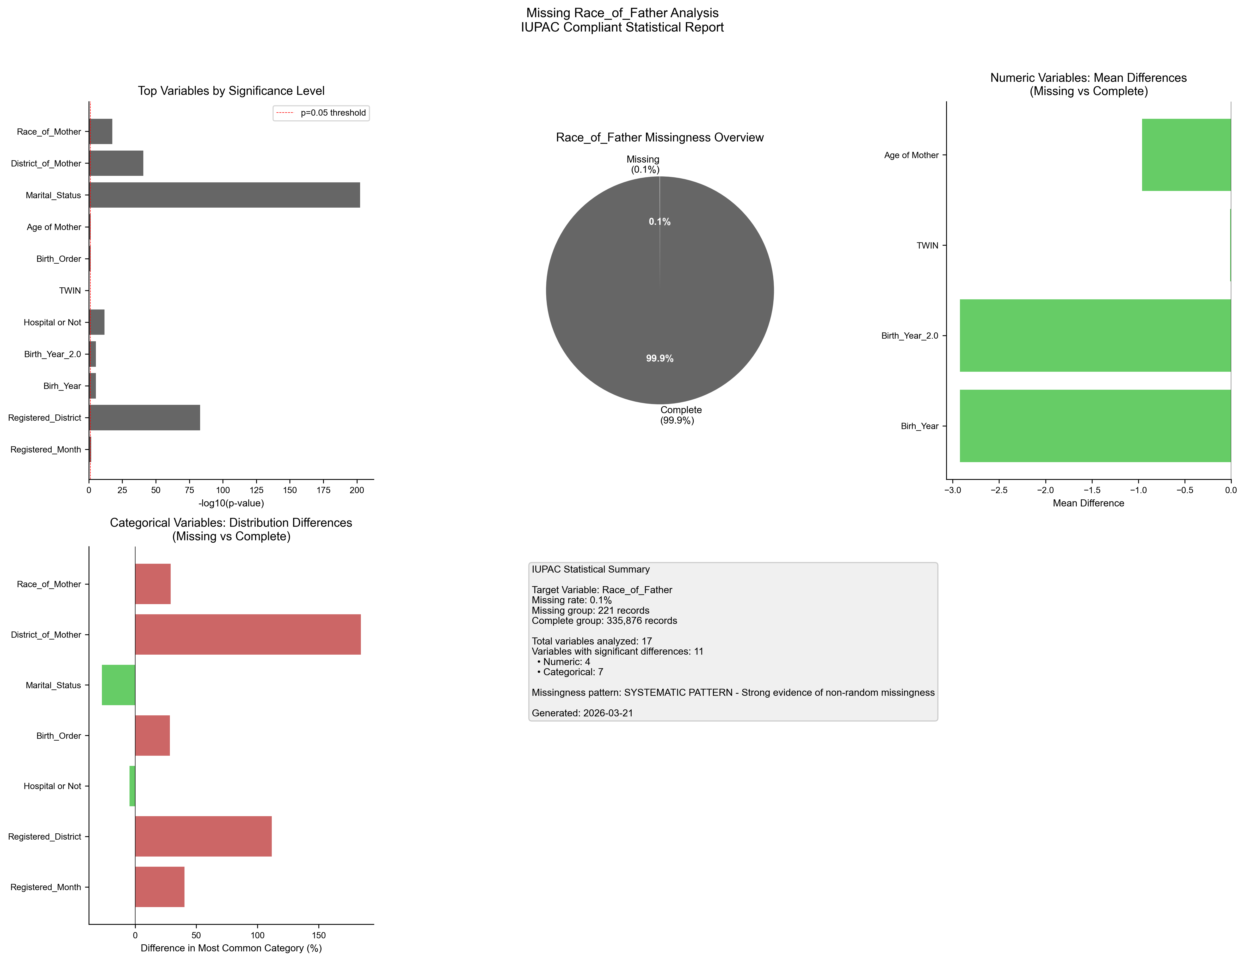
Figure 1. IUPAC compliant statistical visualization of missing Race_of_Father patterns.

5. Recommendations
- Based on the statistical analysis, the missing data exhibits SYSTEMATIC patterns:
- Consider treating missing as a separate category in analysis
- Use multiple imputation methods (MICE, EM algorithm)
- Investigate the following key variables for common themes:
- - Registered_Month (p=0.0139)
- - Registered_District (p=0.0000)
- - Birh_Year (p=0.0000)
- - Birth_Year_2.0 (p=0.0000)
- - Hospital or Not (p=0.0000)
- - TWIN (p=0.0000)
- - Birth_Order (p=0.0423)
- - Age of Mother (p=0.0391)
- - Marital_Status (p=0.0000)
- - District_of_Mother (p=0.0000)
- Document missingness patterns in methodology section

6. Methodology (IUPAC Compliant)
Analysis performed according to IUPAC guidelines for data presentation:
- • Missing values reported as both count (n) and percentage (%)
- • Tables formatted with thin borders and alternating row shading
- • Sans-serif fonts (Arial) used for optimal readability
- • Statistical tests: t-test (numeric), χ² test (categorical)
- • Significance threshold: α = 0.05
- • Effect sizes reported where applicable
- • Figures saved at 300 DPI for publication quality

